Добруски, В. Новооткрита римска военна диплома. СбНУ, ХІV
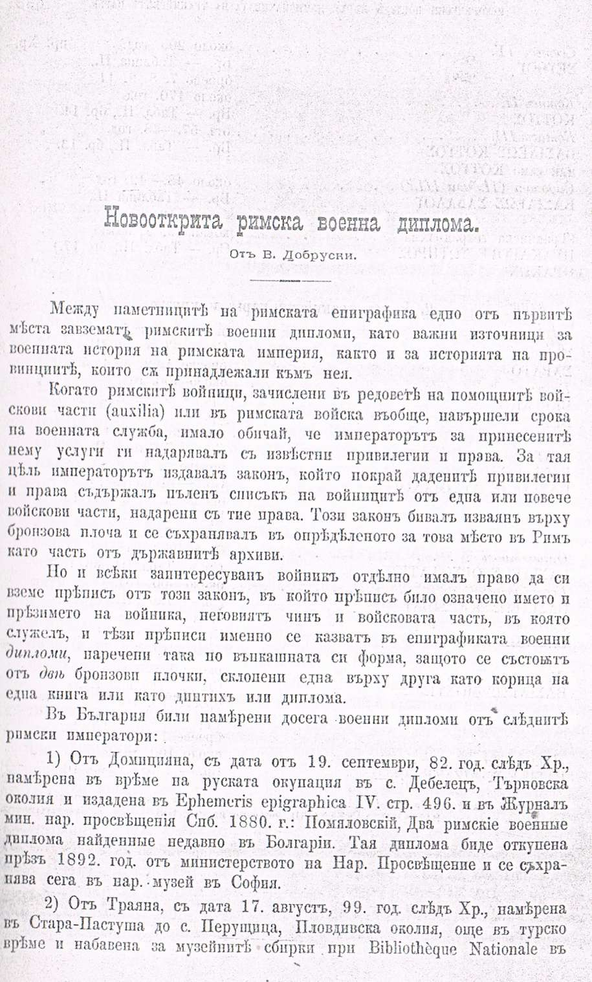

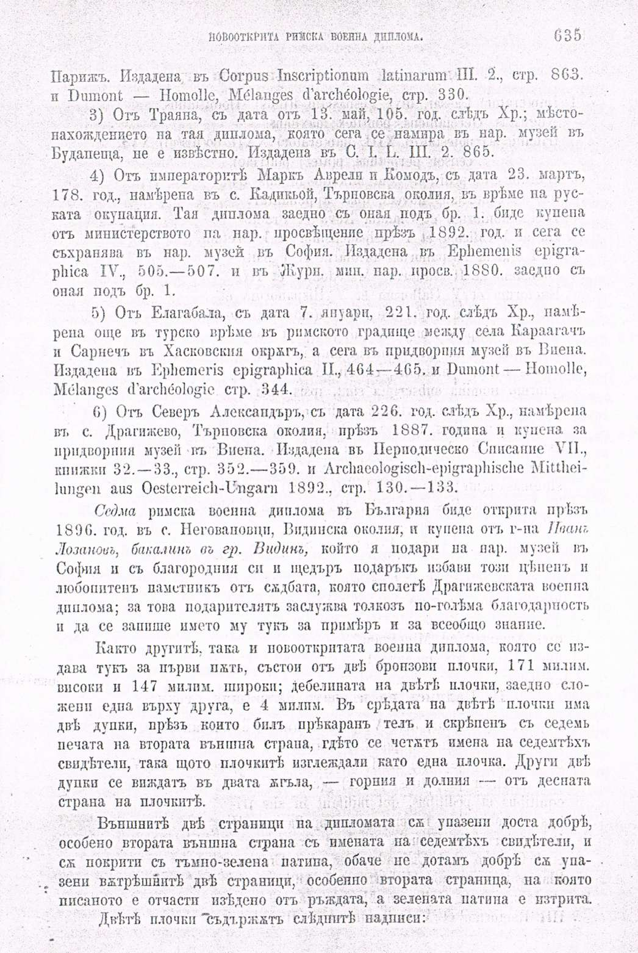

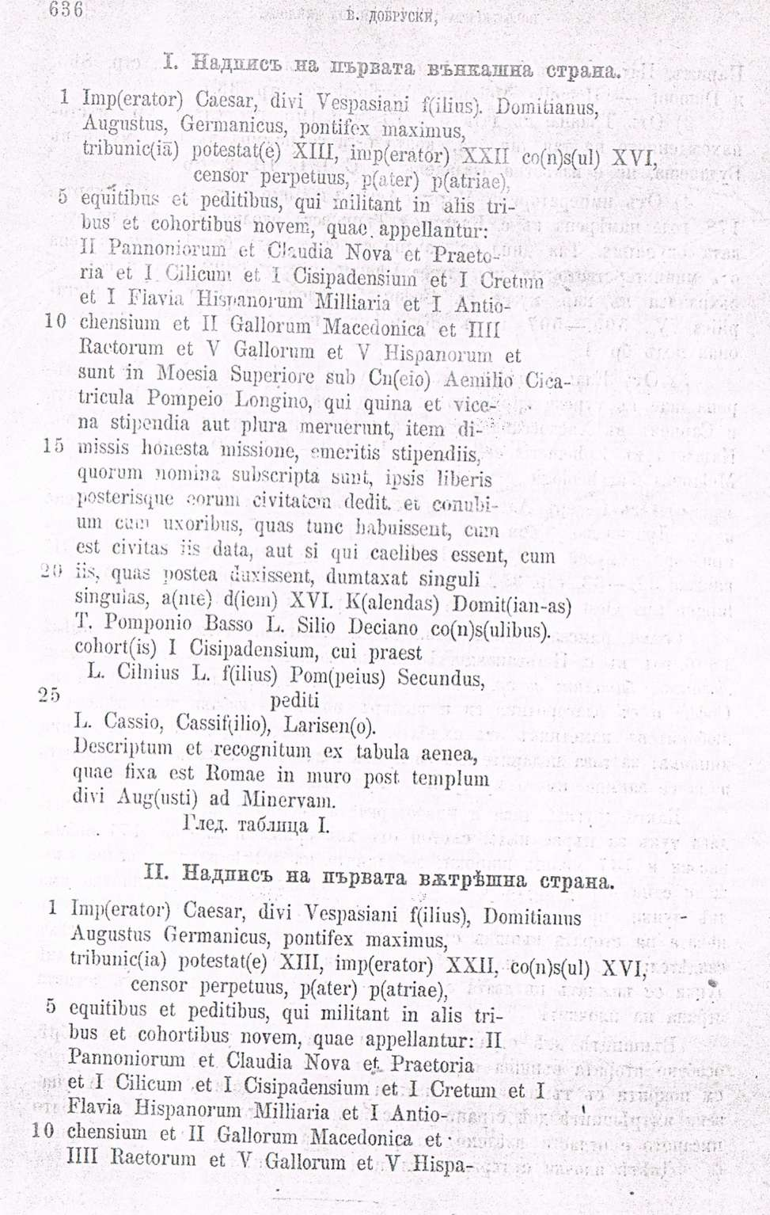

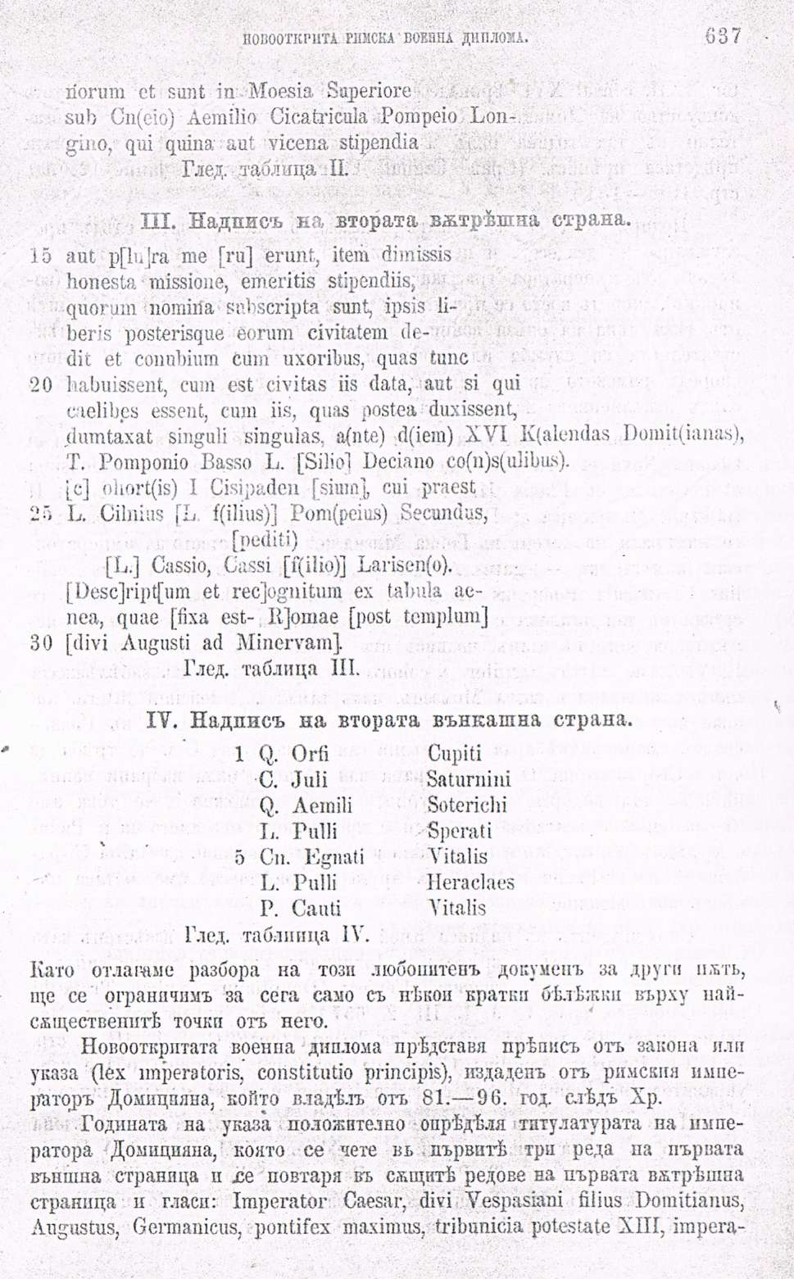

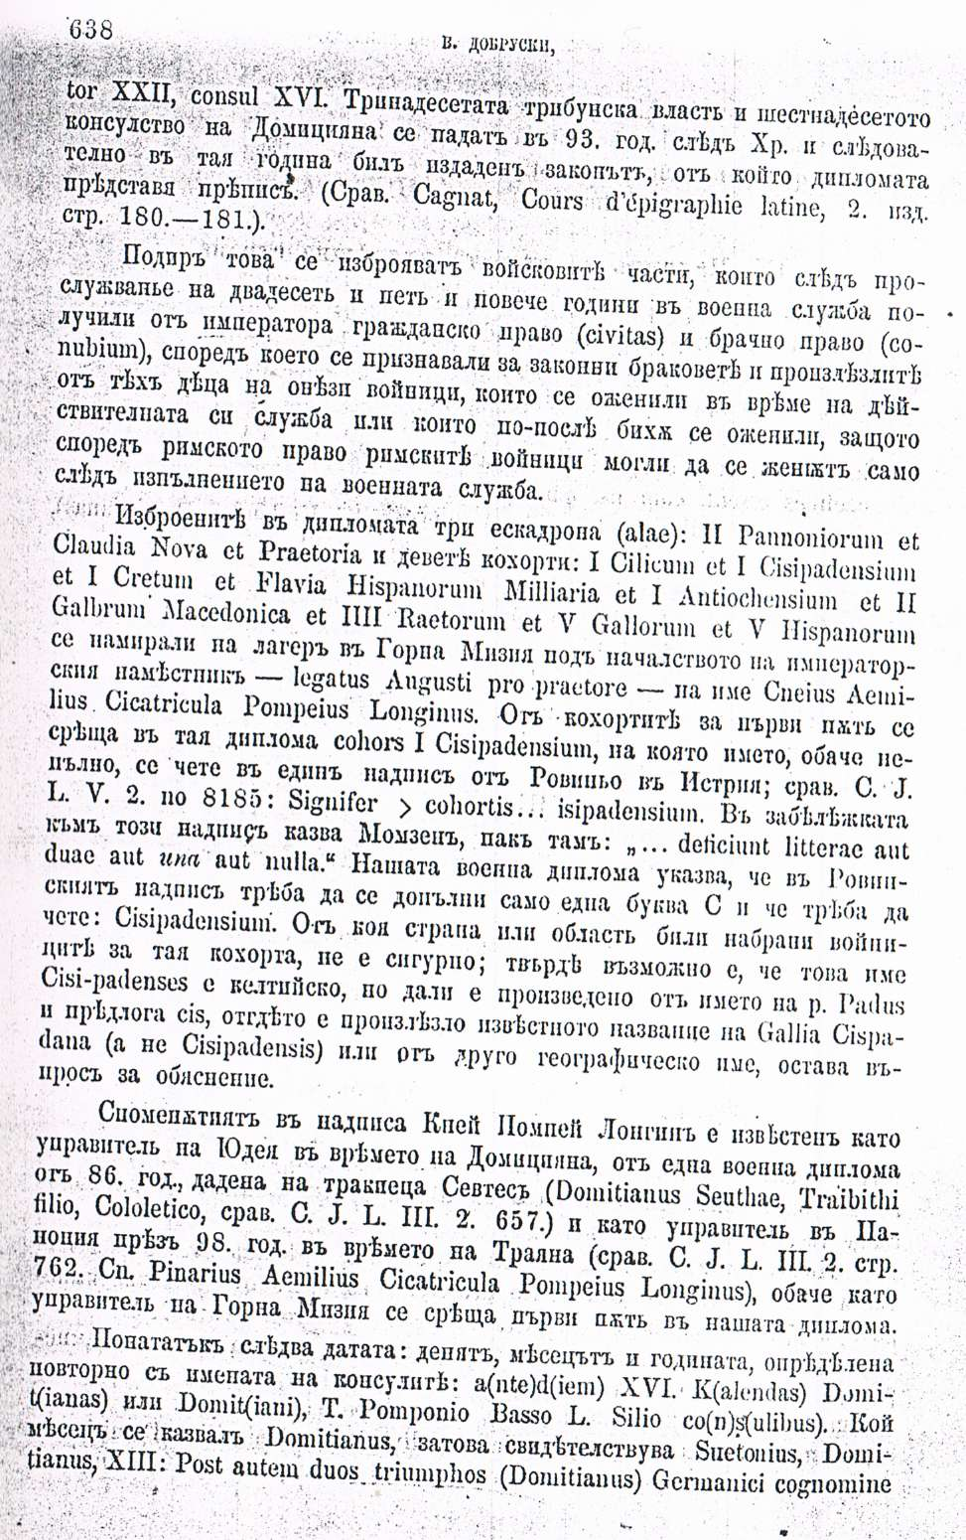

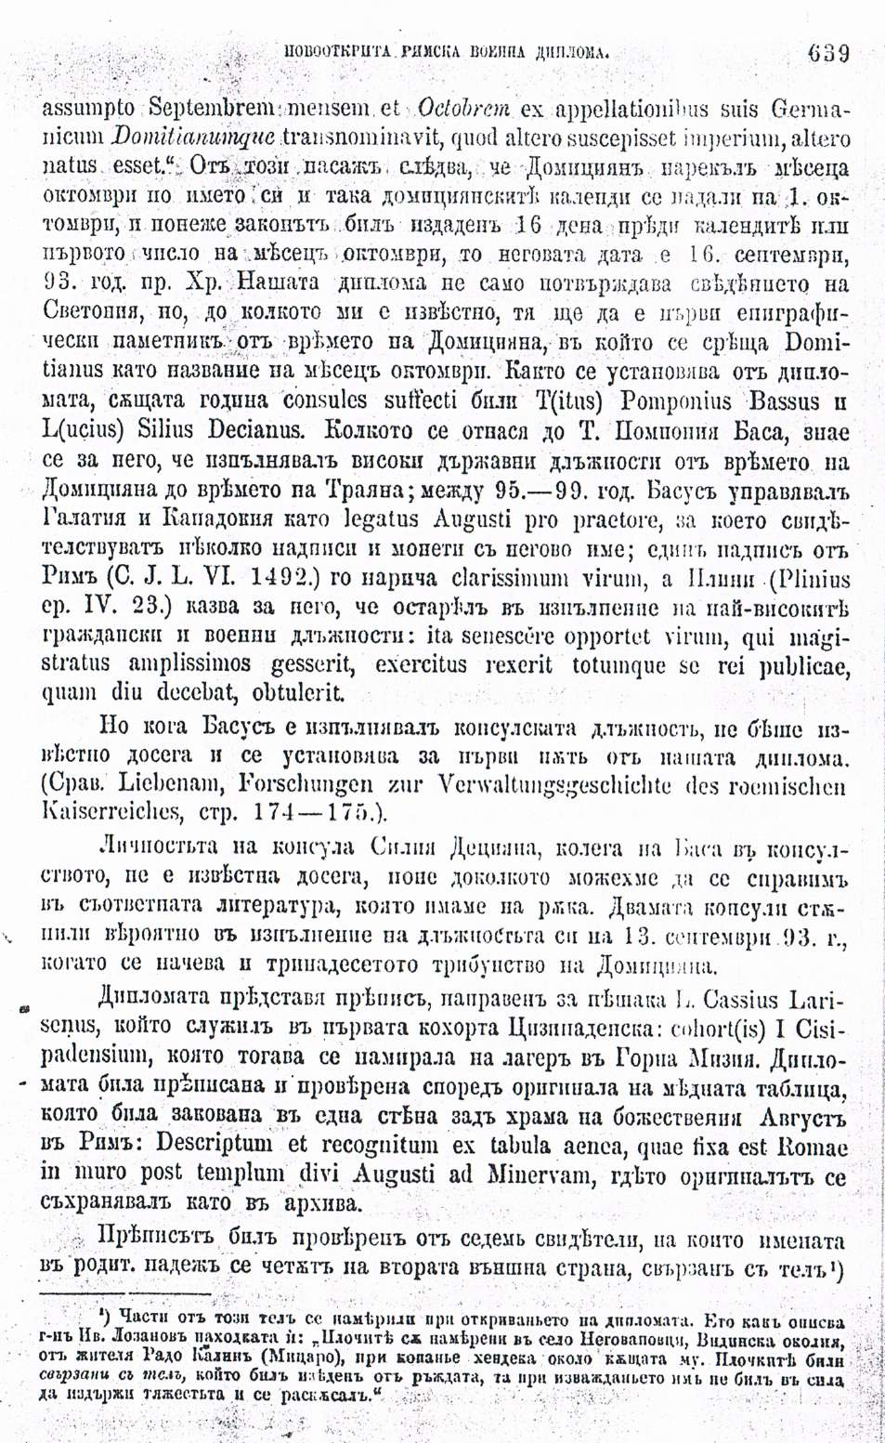

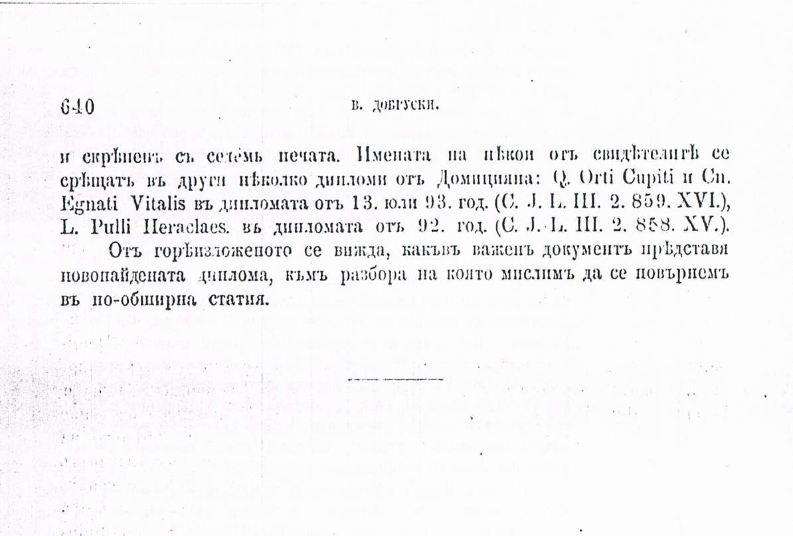

Добруски, В. Новооткрита римска военна диплома. СбНУ, ХІV, 1897, с. 634-640.

INCLUDEPICTURE "http://t0.gstatic.com/images?q=tbn:ANd9GcTDT1jpfS6n_Y4NmsXFnf0dV2uAk854tEHeOSaIXPxUCt7qxHu5xaSaZA" \* MERGEFORMATINET INCLUDEPICTURE "http://t0.gstatic.com/images?q=tbn:ANd9GcTDT1jpfS6n_Y4NmsXFnf0dV2uAk854tEHeOSaIXPxUCt7qxHu5xaSaZA" \* MERGEFORMATINET INCLUDEPICTURE "http://t0.gstatic.com/images?q=tbn:ANd9GcTDT1jpfS6n_Y4NmsXFnf0dV2uAk854tEHeOSaIXPxUCt7qxHu5xaSaZA" \* MERGEFORMATINET INCLUDEPICTURE "http://t0.gstatic.com/images?q=tbn:ANd9GcTDT1jpfS6n_Y4NmsXFnf0dV2uAk854tEHeOSaIXPxUCt7qxHu5xaSaZA" \* MERGEFORMATINET INCLUDEPICTURE "http://t0.gstatic.com/images?q=tbn:ANd9GcTDT1jpfS6n_Y4NmsXFnf0dV2uAk854tEHeOSaIXPxUCt7qxHu5xaSaZA" \* MERGEFORMATINET INCLUDEPICTURE "http://t0.gstatic.com/images?q=tbn:ANd9GcTDT1jpfS6n_Y4NmsXFnf0dV2uAk854tEHeOSaIXPxUCt7qxHu5xaSaZA" \* MERGEFORMATINET INCLUDEPICTURE "http://t0.gstatic.com/images?q=tbn:ANd9GcTDT1jpfS6n_Y4NmsXFnf0dV2uAk854tEHeOSaIXPxUCt7qxHu5xaSaZA" \* MERGEFORMATINET INCLUDEPICTURE "http://t0.gstatic.com/images?q=tbn:ANd9GcTDT1jpfS6n_Y4NmsXFnf0dV2uAk854tEHeOSaIXPxUCt7qxHu5xaSaZA" \* MERGEFORMATINET INCLUDEPICTURE "http://t0.gstatic.com/images?q=tbn:ANd9GcTDT1jpfS6n_Y4NmsXFnf0dV2uAk854tEHeOSaIXPxUCt7qxHu5xaSaZA" \* MERGEFORMATINET INCLUDEPICTURE "http://t0.gstatic.com/images?q=tbn:ANd9GcTDT1jpfS6n_Y4NmsXFnf0dV2uAk854tEHeOSaIXPxUCt7qxHu5xaSaZA" \* MERGEFORMATINET INCLUDEPICTURE "http://t0.gstatic.com/images?q=tbn:ANd9GcTDT1jpfS6n_Y4NmsXFnf0dV2uAk854tEHeOSaIXPxUCt7qxHu5xaSaZA" \* MERGEFORMATINET INCLUDEPICTURE "http://t0.gstatic.com/images?q=tbn:ANd9GcTDT1jpfS6n_Y4NmsXFnf0dV2uAk854tEHeOSaIXPxUCt7qxHu5xaSaZA" \* MERGEFORMATINET INCLUDEPICTURE "http://t0.gstatic.com/images?q=tbn:ANd9GcTDT1jpfS6n_Y4NmsXFnf0dV2uAk854tEHeOSaIXPxUCt7qxHu5xaSaZA" \* MERGEFORMATINET INCLUDEPICTURE "http://t0.gstatic.com/images?q=tbn:ANd9GcTDT1jpfS6n_Y4NmsXFnf0dV2uAk854tEHeOSaIXPxUCt7qxHu5xaSaZA" \* MERGEFORMATINET INCLUDEPICTURE "http://t0.gstatic.com/images?q=tbn:ANd9GcTDT1jpfS6n_Y4NmsXFnf0dV2uAk854tEHeOSaIXPxUCt7qxHu5xaSaZA" \* MERGEFORMATINET INCLUDEPICTURE "http://t0.gstatic.com/images?q=tbn:ANd9GcTDT1jpfS6n_Y4NmsXFnf0dV2uAk854tEHeOSaIXPxUCt7qxHu5xaSaZA" \* MERGEFORMATINET INCLUDEPICTURE "http://t0.gstatic.com/images?q=tbn:ANd9GcTDT1jpfS6n_Y4NmsXFnf0dV2uAk854tEHeOSaIXPxUCt7qxHu5xaSaZA" \* MERGEFORMATINET INCLUDEPICTURE "http://t0.gstatic.com/images?q=tbn:ANd9GcTDT1jpfS6n_Y4NmsXFnf0dV2uAk854tEHeOSaIXPxUCt7qxHu5xaSaZA" \* MERGEFORMATINET INCLUDEPICTURE "http://t0.gstatic.com/images?q=tbn:ANd9GcTDT1jpfS6n_Y4NmsXFnf0dV2uAk854tEHeOSaIXPxUCt7qxHu5xaSaZA" \* MERGEFORMATINET INCLUDEPICTURE "http://t0.gstatic.com/images?q=tbn:ANd9GcTDT1jpfS6n_Y4NmsXFnf0dV2uAk854tEHeOSaIXPxUCt7qxHu5xaSaZA" \* MERGEFORMATINET INCLUDEPICTURE "http://t0.gstatic.com/images?q=tbn:ANd9GcTDT1jpfS6n_Y4NmsXFnf0dV2uAk854tEHeOSaIXPxUCt7qxHu5xaSaZA" \* MERGEFORMATINET INCLUDEPICTURE "http://t0.gstatic.com/images?q=tbn:ANd9GcTDT1jpfS6n_Y4NmsXFnf0dV2uAk854tEHeOSaIXPxUCt7qxHu5xaSaZA" \* MERGEFORMATINET INCLUDEPICTURE "http://t0.gstatic.com/images?q=tbn:ANd9GcTDT1jpfS6n_Y4NmsXFnf0dV2uAk854tEHeOSaIXPxUCt7qxHu5xaSaZA" \* MERGEFORMATINET INCLUDEPICTURE "http://t0.gstatic.com/images?q=tbn:ANd9GcTDT1jpfS6n_Y4NmsXFnf0dV2uAk854tEHeOSaIXPxUCt7qxHu5xaSaZA" \* MERGEFORMATINET INCLUDEPICTURE "http://t0.gstatic.com/images?q=tbn:ANd9GcTDT1jpfS6n_Y4NmsXFnf0dV2uAk854tEHeOSaIXPxUCt7qxHu5xaSaZA" \* MERGEFORMATINET INCLUDEPICTURE "http://t0.gstatic.com/images?q=tbn:ANd9GcTDT1jpfS6n_Y4NmsXFnf0dV2uAk854tEHeOSaIXPxUCt7qxHu5xaSaZA" \* MERGEFORMATINET INCLUDEPICTURE "http://t0.gstatic.com/images?q=tbn:ANd9GcTDT1jpfS6n_Y4NmsXFnf0dV2uAk854tEHeOSaIXPxUCt7qxHu5xaSaZA" \* MERGEFORMATINET INCLUDEPICTURE "http://t0.gstatic.com/images?q=tbn:ANd9GcTDT1jpfS6n_Y4NmsXFnf0dV2uAk854tEHeOSaIXPxUCt7qxHu5xaSaZA" \* MERGEFORMATINET INCLUDEPICTURE "http://t0.gstatic.com/images?q=tbn:ANd9GcTDT1jpfS6n_Y4NmsXFnf0dV2uAk854tEHeOSaIXPxUCt7qxHu5xaSaZA" \* MERGEFORMATINET INCLUDEPICTURE "http://t0.gstatic.com/images?q=tbn:ANd9GcTDT1jpfS6n_Y4NmsXFnf0dV2uAk854tEHeOSaIXPxUCt7qxHu5xaSaZA" \* MERGEFORMATINET INCLUDEPICTURE "http://t0.gstatic.com/images?q=tbn:ANd9GcTDT1jpfS6n_Y4NmsXFnf0dV2uAk854tEHeOSaIXPxUCt7qxHu5xaSaZA" \* MERGEFORMATINET INCLUDEPICTURE "http://t0.gstatic.com/images?q=tbn:ANd9GcTDT1jpfS6n_Y4NmsXFnf0dV2uAk854tEHeOSaIXPxUCt7qxHu5xaSaZA" \* MERGEFORMATINET INCLUDEPICTURE "http://t0.gstatic.com/images?q=tbn:ANd9GcTDT1jpfS6n_Y4NmsXFnf0dV2uAk854tEHeOSaIXPxUCt7qxHu5xaSaZA" \* MERGEFORMATINET INCLUDEPICTURE "http://t0.gstatic.com/images?q=tbn:ANd9GcTDT1jpfS6n_Y4NmsXFnf0dV2uAk854tEHeOSaIXPxUCt7qxHu5xaSaZA" \* MERGEFORMATINET INCLUDEPICTURE "http://t0.gstatic.com/images?q=tbn:ANd9GcTDT1jpfS6n_Y4NmsXFnf0dV2uAk854tEHeOSaIXPxUCt7qxHu5xaSaZA" \* MERGEFORMATINET INCLUDEPICTURE "http://t0.gstatic.com/images?q=tbn:ANd9GcTDT1jpfS6n_Y4NmsXFnf0dV2uAk854tEHeOSaIXPxUCt7qxHu5xaSaZA" \* MERGEFORMATINET INCLUDEPICTURE "http://t0.gstatic.com/images?q=tbn:ANd9GcTDT1jpfS6n_Y4NmsXFnf0dV2uAk854tEHeOSaIXPxUCt7qxHu5xaSaZA" \* MERGEFORMATINET INCLUDEPICTURE "http://t0.gstatic.com/images?q=tbn:ANd9GcTDT1jpfS6n_Y4NmsXFnf0dV2uAk854tEHeOSaIXPxUCt7qxHu5xaSaZA" \* MERGEFORMATINET INCLUDEPICTURE "http://t0.gstatic.com/images?q=tbn:ANd9GcTDT1jpfS6n_Y4NmsXFnf0dV2uAk854tEHeOSaIXPxUCt7qxHu5xaSaZA" \* MERGEFORMATINET INCLUDEPICTURE "http://t0.gstatic.com/images?q=tbn:ANd9GcTDT1jpfS6n_Y4NmsXFnf0dV2uAk854tEHeOSaIXPxUCt7qxHu5xaSaZA" \* MERGEFORMATINET INCLUDEPICTURE "http://t0.gstatic.com/images?q=tbn:ANd9GcTDT1jpfS6n_Y4NmsXFnf0dV2uAk854tEHeOSaIXPxUCt7qxHu5xaSaZA" \* MERGEFORMATINET INCLUDEPICTURE "http://t0.gstatic.com/images?q=tbn:ANd9GcTDT1jpfS6n_Y4NmsXFnf0dV2uAk854tEHeOSaIXPxUCt7qxHu5xaSaZA" \* MERGEFORMATINET INCLUDEPICTURE "http://t0.gstatic.com/images?q=tbn:ANd9GcTDT1jpfS6n_Y4NmsXFnf0dV2uAk854tEHeOSaIXPxUCt7qxHu5xaSaZA" \* MERGEFORMATINET INCLUDEPICTURE "http://t0.gstatic.com/images?q=tbn:ANd9GcTDT1jpfS6n_Y4NmsXFnf0dV2uAk854tEHeOSaIXPxUCt7qxHu5xaSaZA" \* MERGEFORMATINET INCLUDEPICTURE "http://t0.gstatic.com/images?q=tbn:ANd9GcTDT1jpfS6n_Y4NmsXFnf0dV2uAk854tEHeOSaIXPxUCt7qxHu5xaSaZA" \* MERGEFORMATINET INCLUDEPICTURE "http://t0.gstatic.com/images?q=tbn:ANd9GcTDT1jpfS6n_Y4NmsXFnf0dV2uAk854tEHeOSaIXPxUCt7qxHu5xaSaZA" \* MERGEFORMATINET INCLUDEPICTURE "http://t0.gstatic.com/images?q=tbn:ANd9GcTDT1jpfS6n_Y4NmsXFnf0dV2uAk854tEHeOSaIXPxUCt7qxHu5xaSaZA" \* MERGEFORMATINET INCLUDEPICTURE "http://t0.gstatic.com/images?q=tbn:ANd9GcTDT1jpfS6n_Y4NmsXFnf0dV2uAk854tEHeOSaIXPxUCt7qxHu5xaSaZA" \* MERGEFORMATINET INCLUDEPICTURE "http://t0.gstatic.com/images?q=tbn:ANd9GcTDT1jpfS6n_Y4NmsXFnf0dV2uAk854tEHeOSaIXPxUCt7qxHu5xaSaZA" \* MERGEFORMATINET INCLUDEPICTURE "http://t0.gstatic.com/images?q=tbn:ANd9GcTDT1jpfS6n_Y4NmsXFnf0dV2uAk854tEHeOSaIXPxUCt7qxHu5xaSaZA" \* MERGEFORMATINET INCLUDEPICTURE "http://t0.gstatic.com/images?q=tbn:ANd9GcTDT1jpfS6n_Y4NmsXFnf0dV2uAk854tEHeOSaIXPxUCt7qxHu5xaSaZA" \* MERGEFORMATINET INCLUDEPICTURE "http://t0.gstatic.com/images?q=tbn:ANd9GcTDT1jpfS6n_Y4NmsXFnf0dV2uAk854tEHeOSaIXPxUCt7qxHu5xaSaZA" \* MERGEFORMATINET INCLUDEPICTURE "http://t0.gstatic.com/images?q=tbn:ANd9GcTDT1jpfS6n_Y4NmsXFnf0dV2uAk854tEHeOSaIXPxUCt7qxHu5xaSaZA" \* MERGEFORMATINET INCLUDEPICTURE "http://t0.gstatic.com/images?q=tbn:ANd9GcTDT1jpfS6n_Y4NmsXFnf0dV2uAk854tEHeOSaIXPxUCt7qxHu5xaSaZA" \* MERGEFORMATINET INCLUDEPICTURE "http://t0.gstatic.com/images?q=tbn:ANd9GcTDT1jpfS6n_Y4NmsXFnf0dV2uAk854tEHeOSaIXPxUCt7qxHu5xaSaZA" \* MERGEFORMATINET INCLUDEPICTURE "http://t0.gstatic.com/images?q=tbn:ANd9GcTDT1jpfS6n_Y4NmsXFnf0dV2uAk854tEHeOSaIXPxUCt7qxHu5xaSaZA" \* MERGEFORMATINET INCLUDEPICTURE "http://t0.gstatic.com/images?q=tbn:ANd9GcTDT1jpfS6n_Y4NmsXFnf0dV2uAk854tEHeOSaIXPxUCt7qxHu5xaSaZA" \* MERGEFORMATINET INCLUDEPICTURE "http://t0.gstatic.com/images?q=tbn:ANd9GcTDT1jpfS6n_Y4NmsXFnf0dV2uAk854tEHeOSaIXPxUCt7qxHu5xaSaZA" \* MERGEFORMATINET INCLUDEPICTURE "http://t0.gstatic.com/images?q=tbn:ANd9GcTDT1jpfS6n_Y4NmsXFnf0dV2uAk854tEHeOSaIXPxUCt7qxHu5xaSaZA" \* MERGEFORMATINET INCLUDEPICTURE "http://t0.gstatic.com/images?q=tbn:ANd9GcTDT1jpfS6n_Y4NmsXFnf0dV2uAk854tEHeOSaIXPxUCt7qxHu5xaSaZA" \* MERGEFORMATINET INCLUDEPICTURE "http://t0.gstatic.com/images?q=tbn:ANd9GcTDT1jpfS6n_Y4NmsXFnf0dV2uAk854tEHeOSaIXPxUCt7qxHu5xaSaZA" \* MERGEFORMATINET INCLUDEPICTURE "http://t0.gstatic.com/images?q=tbn:ANd9GcTDT1jpfS6n_Y4NmsXFnf0dV2uAk854tEHeOSaIXPxUCt7qxHu5xaSaZA" \* MERGEFORMATINET INCLUDEPICTURE "http://t0.gstatic.com/images?q=tbn:ANd9GcTDT1jpfS6n_Y4NmsXFnf0dV2uAk854tEHeOSaIXPxUCt7qxHu5xaSaZA" \* MERGEFORMATINET INCLUDEPICTURE "http://t0.gstatic.com/images?q=tbn:ANd9GcTDT1jpfS6n_Y4NmsXFnf0dV2uAk854tEHeOSaIXPxUCt7qxHu5xaSaZA" \* MERGEFORMATINET INCLUDEPICTURE "http://t0.gstatic.com/images?q=tbn:ANd9GcTDT1jpfS6n_Y4NmsXFnf0dV2uAk854tEHeOSaIXPxUCt7qxHu5xaSaZA" \* MERGEFORMATINET INCLUDEPICTURE "http://t0.gstatic.com/images?q=tbn:ANd9GcTDT1jpfS6n_Y4NmsXFnf0dV2uAk854tEHeOSaIXPxUCt7qxHu5xaSaZA" \* MERGEFORMATINET INCLUDEPICTURE "http://t0.gstatic.com/images?q=tbn:ANd9GcTDT1jpfS6n_Y4NmsXFnf0dV2uAk854tEHeOSaIXPxUCt7qxHu5xaSaZA" \* MERGEFORMATINET INCLUDEPICTURE "http://t0.gstatic.com/images?q=tbn:ANd9GcTDT1jpfS6n_Y4NmsXFnf0dV2uAk854tEHeOSaIXPxUCt7qxHu5xaSaZA" \* MERGEFORMATINET INCLUDEPICTURE "http://t0.gstatic.com/images?q=tbn:ANd9GcTDT1jpfS6n_Y4NmsXFnf0dV2uAk854tEHeOSaIXPxUCt7qxHu5xaSaZA" \* MERGEFORMATINET INCLUDEPICTURE "http://t0.gstatic.com/images?q=tbn:ANd9GcTDT1jpfS6n_Y4NmsXFnf0dV2uAk854tEHeOSaIXPxUCt7qxHu5xaSaZA" \* MERGEFORMATINET INCLUDEPICTURE "http://t0.gstatic.com/images?q=tbn:ANd9GcTDT1jpfS6n_Y4NmsXFnf0dV2uAk854tEHeOSaIXPxUCt7qxHu5xaSaZA" \* MERGEFORMATINET INCLUDEPICTURE "http://t0.gstatic.com/images?q=tbn:ANd9GcTDT1jpfS6n_Y4NmsXFnf0dV2uAk854tEHeOSaIXPxUCt7qxHu5xaSaZA" \* MERGEFORMATINET INCLUDEPICTURE "http://t0.gstatic.com/images?q=tbn:ANd9GcTDT1jpfS6n_Y4NmsXFnf0dV2uAk854tEHeOSaIXPxUCt7qxHu5xaSaZA" \* MERGEFORMATINET INCLUDEPICTURE "http://t0.gstatic.com/images?q=tbn:ANd9GcTDT1jpfS6n_Y4NmsXFnf0dV2uAk854tEHeOSaIXPxUCt7qxHu5xaSaZA" \* MERGEFORMATINET INCLUDEPICTURE "http://t0.gstatic.com/images?q=tbn:ANd9GcTDT1jpfS6n_Y4NmsXFnf0dV2uAk854tEHeOSaIXPxUCt7qxHu5xaSaZA" \* MERGEFORMATINET INCLUDEPICTURE "http://t0.gstatic.com/images?q=tbn:ANd9GcTDT1jpfS6n_Y4NmsXFnf0dV2uAk854tEHeOSaIXPxUCt7qxHu5xaSaZA" \* MERGEFORMATINET INCLUDEPICTURE "http://t0.gstatic.com/images?q=tbn:ANd9GcTDT1jpfS6n_Y4NmsXFnf0dV2uAk854tEHeOSaIXPxUCt7qxHu5xaSaZA" \* MERGEFORMATINET INCLUDEPICTURE "http://t0.gstatic.com/images?q=tbn:ANd9GcTDT1jpfS6n_Y4NmsXFnf0dV2uAk854tEHeOSaIXPxUCt7qxHu5xaSaZA" \* MERGEFORMATINET INCLUDEPICTURE "http://t0.gstatic.com/images?q=tbn:ANd9GcTDT1jpfS6n_Y4NmsXFnf0dV2uAk854tEHeOSaIXPxUCt7qxHu5xaSaZA" \* MERGEFORMATINET INCLUDEPICTURE "http://t0.gstatic.com/images?q=tbn:ANd9GcTDT1jpfS6n_Y4NmsXFnf0dV2uAk854tEHeOSaIXPxUCt7qxHu5xaSaZA" \* MERGEFORMATINET INCLUDEPICTURE "http://t0.gstatic.com/images?q=tbn:ANd9GcTDT1jpfS6n_Y4NmsXFnf0dV2uAk854tEHeOSaIXPxUCt7qxHu5xaSaZA" \* MERGEFORMATINET INCLUDEPICTURE "http://t0.gstatic.com/images?q=tbn:ANd9GcTDT1jpfS6n_Y4NmsXFnf0dV2uAk854tEHeOSaIXPxUCt7qxHu5xaSaZA" \* MERGEFORMATINET INCLUDEPICTURE "http://t0.gstatic.com/images?q=tbn:ANd9GcTDT1jpfS6n_Y4NmsXFnf0dV2uAk854tEHeOSaIXPxUCt7qxHu5xaSaZA" \* MERGEFORMATINET INCLUDEPICTURE "http://t0.gstatic.com/images?q=tbn:ANd9GcTDT1jpfS6n_Y4NmsXFnf0dV2uAk854tEHeOSaIXPxUCt7qxHu5xaSaZA" \* MERGEFORMATINET INCLUDEPICTURE "http://t0.gstatic.com/images?q=tbn:ANd9GcTDT1jpfS6n_Y4NmsXFnf0dV2uAk854tEHeOSaIXPxUCt7qxHu5xaSaZA" \* MERGEFORMATINET INCLUDEPICTURE "http://t0.gstatic.com/images?q=tbn:ANd9GcTDT1jpfS6n_Y4NmsXFnf0dV2uAk854tEHeOSaIXPxUCt7qxHu5xaSaZA" \* MERGEFORMATINET INCLUDEPICTURE "http://t0.gstatic.com/images?q=tbn:ANd9GcTDT1jpfS6n_Y4NmsXFnf0dV2uAk854tEHeOSaIXPxUCt7qxHu5xaSaZA" \* MERGEFORMATINET INCLUDEPICTURE "http://t0.gstatic.com/images?q=tbn:ANd9GcTDT1jpfS6n_Y4NmsXFnf0dV2uAk854tEHeOSaIXPxUCt7qxHu5xaSaZA" \* MERGEFORMATINET INCLUDEPICTURE "http://t0.gstatic.com/images?q=tbn:ANd9GcTDT1jpfS6n_Y4NmsXFnf0dV2uAk854tEHeOSaIXPxUCt7qxHu5xaSaZA" \* MERGEFORMATINET INCLUDEPICTURE "http://t0.gstatic.com/images?q=tbn:ANd9GcTDT1jpfS6n_Y4NmsXFnf0dV2uAk854tEHeOSaIXPxUCt7qxHu5xaSaZA" \* MERGEFORMATINET INCLUDEPICTURE "http://t0.gstatic.com/images?q=tbn:ANd9GcTDT1jpfS6n_Y4NmsXFnf0dV2uAk854tEHeOSaIXPxUCt7qxHu5xaSaZA" \* MERGEFORMATINET INCLUDEPICTURE "http://t0.gstatic.com/images?q=tbn:ANd9GcTDT1jpfS6n_Y4NmsXFnf0dV2uAk854tEHeOSaIXPxUCt7qxHu5xaSaZA" \* MERGEFORMATINET INCLUDEPICTURE "http://t0.gstatic.com/images?q=tbn:ANd9GcTDT1jpfS6n_Y4NmsXFnf0dV2uAk854tEHeOSaIXPxUCt7qxHu5xaSaZA" \* MERGEFORMATINET INCLUDEPICTURE "http://t0.gstatic.com/images?q=tbn:ANd9GcTDT1jpfS6n_Y4NmsXFnf0dV2uAk854tEHeOSaIXPxUCt7qxHu5xaSaZA" \* MERGEFORMATINET INCLUDEPICTURE "http://t0.gstatic.com/images?q=tbn:ANd9GcTDT1jpfS6n_Y4NmsXFnf0dV2uAk854tEHeOSaIXPxUCt7qxHu5xaSaZA" \* MERGEFORMATINET INCLUDEPICTURE "http://t0.gstatic.com/images?q=tbn:ANd9GcTDT1jpfS6n_Y4NmsXFnf0dV2uAk854tEHeOSaIXPxUCt7qxHu5xaSaZA" \* MERGEFORMATINET INCLUDEPICTURE "http://t0.gstatic.com/images?q=tbn:ANd9GcTDT1jpfS6n_Y4NmsXFnf0dV2uAk854tEHeOSaIXPxUCt7qxHu5xaSaZA" \* MERGEFORMATINET INCLUDEPICTURE "http://t0.gstatic.com/images?q=tbn:ANd9GcTDT1jpfS6n_Y4NmsXFnf0dV2uAk854tEHeOSaIXPxUCt7qxHu5xaSaZA" \* MERGEFORMATINET INCLUDEPICTURE "http://t0.gstatic.com/images?q=tbn:ANd9GcTDT1jpfS6n_Y4NmsXFnf0dV2uAk854tEHeOSaIXPxUCt7qxHu5xaSaZA" \* MERGEFORMATINET INCLUDEPICTURE "http://t0.gstatic.com/images?q=tbn:ANd9GcTDT1jpfS6n_Y4NmsXFnf0dV2uAk854tEHeOSaIXPxUCt7qxHu5xaSaZA" \* MERGEFORMATINET INCLUDEPICTURE "http://t0.gstatic.com/images?q=tbn:ANd9GcTDT1jpfS6n_Y4NmsXFnf0dV2uAk854tEHeOSaIXPxUCt7qxHu5xaSaZA" \* MERGEFORMATINET INCLUDEPICTURE "http://t0.gstatic.com/images?q=tbn:ANd9GcTDT1jpfS6n_Y4NmsXFnf0dV2uAk854tEHeOSaIXPxUCt7qxHu5xaSaZA" \* MERGEFORMATINET INCLUDEPICTURE "http://t0.gstatic.com/images?q=tbn:ANd9GcTDT1jpfS6n_Y4NmsXFnf0dV2uAk854tEHeOSaIXPxUCt7qxHu5xaSaZA" \* MERGEFORMATINET INCLUDEPICTURE "http://t0.gstatic.com/images?q=tbn:ANd9GcTDT1jpfS6n_Y4NmsXFnf0dV2uAk854tEHeOSaIXPxUCt7qxHu5xaSaZA" \* MERGEFORMATINET INCLUDEPICTURE "http://t0.gstatic.com/images?q=tbn:ANd9GcTDT1jpfS6n_Y4NmsXFnf0dV2uAk854tEHeOSaIXPxUCt7qxHu5xaSaZA" \* MERGEFORMATINET INCLUDEPICTURE "http://t0.gstatic.com/images?q=tbn:ANd9GcTDT1jpfS6n_Y4NmsXFnf0dV2uAk854tEHeOSaIXPxUCt7qxHu5xaSaZA" \* MERGEFORMATINET INCLUDEPICTURE "http://t0.gstatic.com/images?q=tbn:ANd9GcTDT1jpfS6n_Y4NmsXFnf0dV2uAk854tEHeOSaIXPxUCt7qxHu5xaSaZA" \* MERGEFORMATINET INCLUDEPICTURE "http://t0.gstatic.com/images?q=tbn:ANd9GcTDT1jpfS6n_Y4NmsXFnf0dV2uAk854tEHeOSaIXPxUCt7qxHu5xaSaZA" \* MERGEFORMATINET INCLUDEPICTURE "http://t0.gstatic.com/images?q=tbn:ANd9GcTDT1jpfS6n_Y4NmsXFnf0dV2uAk854tEHeOSaIXPxUCt7qxHu5xaSaZA" \* MERGEFORMATINET INCLUDEPICTURE "http://t0.gstatic.com/images?q=tbn:ANd9GcTDT1jpfS6n_Y4NmsXFnf0dV2uAk854tEHeOSaIXPxUCt7qxHu5xaSaZA" \* MERGEFORMATINET INCLUDEPICTURE "http://t0.gstatic.com/images?q=tbn:ANd9GcTDT1jpfS6n_Y4NmsXFnf0dV2uAk854tEHeOSaIXPxUCt7qxHu5xaSaZA" \* MERGEFORMATINET INCLUDEPICTURE "http://t0.gstatic.com/images?q=tbn:ANd9GcTDT1jpfS6n_Y4NmsXFnf0dV2uAk854tEHeOSaIXPxUCt7qxHu5xaSaZA" \* MERGEFORMATINET INCLUDEPICTURE "http://t0.gstatic.com/images?q=tbn:ANd9GcTDT1jpfS6n_Y4NmsXFnf0dV2uAk854tEHeOSaIXPxUCt7qxHu5xaSaZA" \* MERGEFORMATINET INCLUDEPICTURE "http://t0.gstatic.com/images?q=tbn:ANd9GcTDT1jpfS6n_Y4NmsXFnf0dV2uAk854tEHeOSaIXPxUCt7qxHu5xaSaZA" \* MERGEFORMATINET INCLUDEPICTURE "http://t0.gstatic.com/images?q=tbn:ANd9GcTDT1jpfS6n_Y4NmsXFnf0dV2uAk854tEHeOSaIXPxUCt7qxHu5xaSaZA" \* MERGEFORMATINET INCLUDEPICTURE "http://t0.gstatic.com/images?q=tbn:ANd9GcTDT1jpfS6n_Y4NmsXFnf0dV2uAk854tEHeOSaIXPxUCt7qxHu5xaSaZA" \* MERGEFORMATINET INCLUDEPICTURE "http://t0.gstatic.com/images?q=tbn:ANd9GcTDT1jpfS6n_Y4NmsXFnf0dV2uAk854tEHeOSaIXPxUCt7qxHu5xaSaZA" \* MERGEFORMATINET INCLUDEPICTURE "http://t0.gstatic.com/images?q=tbn:ANd9GcTDT1jpfS6n_Y4NmsXFnf0dV2uAk854tEHeOSaIXPxUCt7qxHu5xaSaZA" \* MERGEFORMATINET INCLUDEPICTURE "http://t0.gstatic.com/images?q=tbn:ANd9GcTDT1jpfS6n_Y4NmsXFnf0dV2uAk854tEHeOSaIXPxUCt7qxHu5xaSaZA" \* MERGEFORMATINET INCLUDEPICTURE "http://t0.gstatic.com/images?q=tbn:ANd9GcTDT1jpfS6n_Y4NmsXFnf0dV2uAk854tEHeOSaIXPxUCt7qxHu5xaSaZA" \* MERGEFORMATINET INCLUDEPICTURE "http://t0.gstatic.com/images?q=tbn:ANd9GcTDT1jpfS6n_Y4NmsXFnf0dV2uAk854tEHeOSaIXPxUCt7qxHu5xaSaZA" \* MERGEFORMATINET INCLUDEPICTURE "http://t0.gstatic.com/images?q=tbn:ANd9GcTDT1jpfS6n_Y4NmsXFnf0dV2uAk854tEHeOSaIXPxUCt7qxHu5xaSaZA" \* MERGEFORMATINET INCLUDEPICTURE "http://t0.gstatic.com/images?q=tbn:ANd9GcTDT1jpfS6n_Y4NmsXFnf0dV2uAk854tEHeOSaIXPxUCt7qxHu5xaSaZA" \* MERGEFORMATINET INCLUDEPICTURE "http://t0.gstatic.com/images?q=tbn:ANd9GcTDT1jpfS6n_Y4NmsXFnf0dV2uAk854tEHeOSaIXPxUCt7qxHu5xaSaZA" \* MERGEFORMATINET INCLUDEPICTURE "http://t0.gstatic.com/images?q=tbn:ANd9GcTDT1jpfS6n_Y4NmsXFnf0dV2uAk854tEHeOSaIXPxUCt7qxHu5xaSaZA" \* MERGEFORMATINET INCLUDEPICTURE "http://t0.gstatic.com/images?q=tbn:ANd9GcTDT1jpfS6n_Y4NmsXFnf0dV2uAk854tEHeOSaIXPxUCt7qxHu5xaSaZA" \* MERGEFORMATINET INCLUDEPICTURE "http://t0.gstatic.com/images?q=tbn:ANd9GcTDT1jpfS6n_Y4NmsXFnf0dV2uAk854tEHeOSaIXPxUCt7qxHu5xaSaZA" \* MERGEFORMATINET INCLUDEPICTURE "http://t0.gstatic.com/images?q=tbn:ANd9GcTDT1jpfS6n_Y4NmsXFnf0dV2uAk854tEHeOSaIXPxUCt7qxHu5xaSaZA" \* MERGEFORMATINET INCLUDEPICTURE "http://t0.gstatic.com/images?q=tbn:ANd9GcTDT1jpfS6n_Y4NmsXFnf0dV2uAk854tEHeOSaIXPxUCt7qxHu5xaSaZA" \* MERGEFORMATINET INCLUDEPICTURE "http://t0.gstatic.com/images?q=tbn:ANd9GcTDT1jpfS6n_Y4NmsXFnf0dV2uAk854tEHeOSaIXPxUCt7qxHu5xaSaZA" \* MERGEFORMATINET INCLUDEPICTURE "http://t0.gstatic.com/images?q=tbn:ANd9GcTDT1jpfS6n_Y4NmsXFnf0dV2uAk854tEHeOSaIXPxUCt7qxHu5xaSaZA" \* MERGEFORMATINET INCLUDEPICTURE "http://t0.gstatic.com/images?q=tbn:ANd9GcTDT1jpfS6n_Y4NmsXFnf0dV2uAk854tEHeOSaIXPxUCt7qxHu5xaSaZA" \* MERGEFORMATINET INCLUDEPICTURE "http://t0.gstatic.com/images?q=tbn:ANd9GcTDT1jpfS6n_Y4NmsXFnf0dV2uAk854tEHeOSaIXPxUCt7qxHu5xaSaZA" \* MERGEFORMATINET INCLUDEPICTURE "http://t0.gstatic.com/images?q=tbn:ANd9GcTDT1jpfS6n_Y4NmsXFnf0dV2uAk854tEHeOSaIXPxUCt7qxHu5xaSaZA" \* MERGEFORMATINET INCLUDEPICTURE "http://t0.gstatic.com/images?q=tbn:ANd9GcTDT1jpfS6n_Y4NmsXFnf0dV2uAk854tEHeOSaIXPxUCt7qxHu5xaSaZA" \* MERGEFORMATINET INCLUDEPICTURE "http://t0.gstatic.com/images?q=tbn:ANd9GcTDT1jpfS6n_Y4NmsXFnf0dV2uAk854tEHeOSaIXPxUCt7qxHu5xaSaZA" \* MERGEFORMATINET INCLUDEPICTURE "http://t0.gstatic.com/images?q=tbn:ANd9GcTDT1jpfS6n_Y4NmsXFnf0dV2uAk854tEHeOSaIXPxUCt7qxHu5xaSaZA" \* MERGEFORMATINET INCLUDEPICTURE "http://t0.gstatic.com/images?q=tbn:ANd9GcTDT1jpfS6n_Y4NmsXFnf0dV2uAk854tEHeOSaIXPxUCt7qxHu5xaSaZA" \* MERGEFORMATINET INCLUDEPICTURE "http://t0.gstatic.com/images?q=tbn:ANd9GcTDT1jpfS6n_Y4NmsXFnf0dV2uAk854tEHeOSaIXPxUCt7qxHu5xaSaZA" \* MERGEFORMATINET INCLUDEPICTURE "http://t0.gstatic.com/images?q=tbn:ANd9GcTDT1jpfS6n_Y4NmsXFnf0dV2uAk854tEHeOSaIXPxUCt7qxHu5xaSaZA" \* MERGEFORMATINET INCLUDEPICTURE "http://t0.gstatic.com/images?q=tbn:ANd9GcTDT1jpfS6n_Y4NmsXFnf0dV2uAk854tEHeOSaIXPxUCt7qxHu5xaSaZA" \* MERGEFORMATINET INCLUDEPICTURE "http://t0.gstatic.com/images?q=tbn:ANd9GcTDT1jpfS6n_Y4NmsXFnf0dV2uAk854tEHeOSaIXPxUCt7qxHu5xaSaZA" \* MERGEFORMATINET INCLUDEPICTURE "http://t0.gstatic.com/images?q=tbn:ANd9GcTDT1jpfS6n_Y4NmsXFnf0dV2uAk854tEHeOSaIXPxUCt7qxHu5xaSaZA" \* MERGEFORMATINET INCLUDEPICTURE "http://t0.gstatic.com/images?q=tbn:ANd9GcTDT1jpfS6n_Y4NmsXFnf0dV2uAk854tEHeOSaIXPxUCt7qxHu5xaSaZA" \* MERGEFORMATINET INCLUDEPICTURE "http://t0.gstatic.com/images?q=tbn:ANd9GcTDT1jpfS6n_Y4NmsXFnf0dV2uAk854tEHeOSaIXPxUCt7qxHu5xaSaZA" \* MERGEFORMATINET INCLUDEPICTURE "http://t0.gstatic.com/images?q=tbn:ANd9GcTDT1jpfS6n_Y4NmsXFnf0dV2uAk854tEHeOSaIXPxUCt7qxHu5xaSaZA" \* MERGEFORMATINET INCLUDEPICTURE "http://t0.gstatic.com/images?q=tbn:ANd9GcTDT1jpfS6n_Y4NmsXFnf0dV2uAk854tEHeOSaIXPxUCt7qxHu5xaSaZA" \* MERGEFORMATINET INCLUDEPICTURE "http://t0.gstatic.com/images?q=tbn:ANd9GcTDT1jpfS6n_Y4NmsXFnf0dV2uAk854tEHeOSaIXPxUCt7qxHu5xaSaZA" \* MERGEFORMATINET INCLUDEPICTURE "http://t0.gstatic.com/images?q=tbn:ANd9GcTDT1jpfS6n_Y4NmsXFnf0dV2uAk854tEHeOSaIXPxUCt7qxHu5xaSaZA" \* MERGEFORMATINET INCLUDEPICTURE "http://t0.gstatic.com/images?q=tbn:ANd9GcTDT1jpfS6n_Y4NmsXFnf0dV2uAk854tEHeOSaIXPxUCt7qxHu5xaSaZA" \* MERGEFORMATINET INCLUDEPICTURE "http://t0.gstatic.com/images?q=tbn:ANd9GcTDT1jpfS6n_Y4NmsXFnf0dV2uAk854tEHeOSaIXPxUCt7qxHu5xaSaZA" \* MERGEFORMATINET INCLUDEPICTURE "http://t0.gstatic.com/images?q=tbn:ANd9GcTDT1jpfS6n_Y4NmsXFnf0dV2uAk854tEHeOSaIXPxUCt7qxHu5xaSaZA" \* MERGEFORMATINET INCLUDEPICTURE "http://t0.gstatic.com/images?q=tbn:ANd9GcTDT1jpfS6n_Y4NmsXFnf0dV2uAk854tEHeOSaIXPxUCt7qxHu5xaSaZA" \* MERGEFORMATINET INCLUDEPICTURE "http://t0.gstatic.com/images?q=tbn:ANd9GcTDT1jpfS6n_Y4NmsXFnf0dV2uAk854tEHeOSaIXPxUCt7qxHu5xaSaZA" \* MERGEFORMATINET INCLUDEPICTURE "http://t0.gstatic.com/images?q=tbn:ANd9GcTDT1jpfS6n_Y4NmsXFnf0dV2uAk854tEHeOSaIXPxUCt7qxHu5xaSaZA" \* MERGEFORMATINET INCLUDEPICTURE "http://t0.gstatic.com/images?q=tbn:ANd9GcTDT1jpfS6n_Y4NmsXFnf0dV2uAk854tEHeOSaIXPxUCt7qxHu5xaSaZA" \* MERGEFORMATINET INCLUDEPICTURE "http://t0.gstatic.com/images?q=tbn:ANd9GcTDT1jpfS6n_Y4NmsXFnf0dV2uAk854tEHeOSaIXPxUCt7qxHu5xaSaZA" \* MERGEFORMATINET INCLUDEPICTURE "http://t0.gstatic.com/images?q=tbn:ANd9GcTDT1jpfS6n_Y4NmsXFnf0dV2uAk854tEHeOSaIXPxUCt7qxHu5xaSaZA" \* MERGEFORMATINET INCLUDEPICTURE "http://t0.gstatic.com/images?q=tbn:ANd9GcTDT1jpfS6n_Y4NmsXFnf0dV2uAk854tEHeOSaIXPxUCt7qxHu5xaSaZA" \* MERGEFORMATINET INCLUDEPICTURE "http://t0.gstatic.com/images?q=tbn:ANd9GcTDT1jpfS6n_Y4NmsXFnf0dV2uAk854tEHeOSaIXPxUCt7qxHu5xaSaZA" \* MERGEFORMATINET
Compiler FLN

